Farmer survey report

The following report is based on the CLUA farmer registration in India. The analysis will be basically on descriptive statistics, this will involve having the data visualizations, frequencies and summary statistics.

We had different files, the files were merged producing 125 variables and I concentrated on the second half of the variables that is from 64-125.

Figure 1: practices used in response to climate change

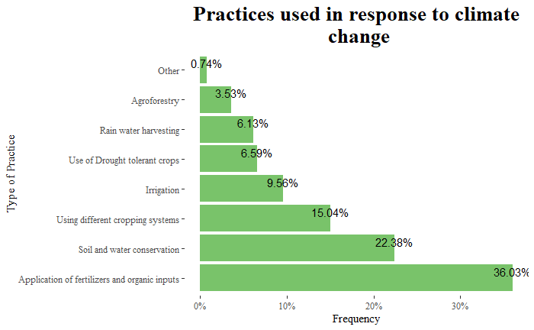

Figure 1 gives a clear overview of the practices the farmers used in response to climate change, application of fertilizers and organic inputs was the most used practice followed by soil and water conservation and then use of different cropping systems.

Figure 2: agricultural advice

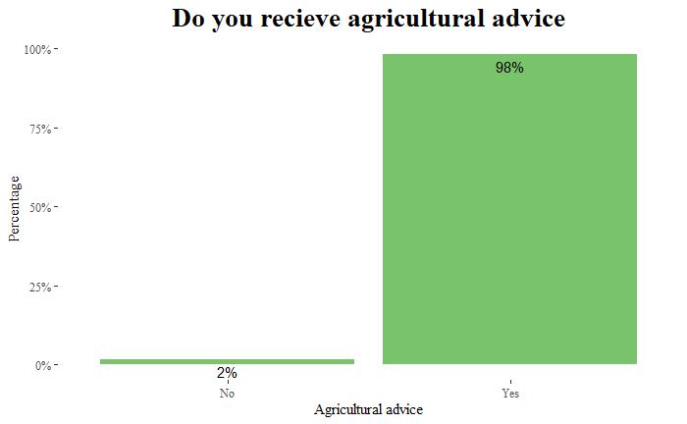

Figure 2 gives the frequency of farmers who do receive agricultural advice, 98% of the farmers receive the advice this means that only 2% do not receive the advice.

Figure 3: sources of agricultural advice

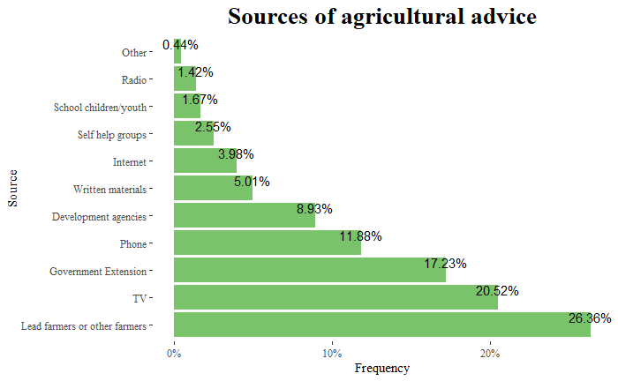

From the 98% who receive the advice we were wanted to know where mostly did they get the advice from and this figure 3 shows that 26.36% got the advice from lead farmers or other farmers, 20.52% from the TV, 17.23% from Government extensions. The fourth source on the list is from the phone. Other sources of advice that they get from is APCNF and farmer organisations.

Figure 4: Most preferred source

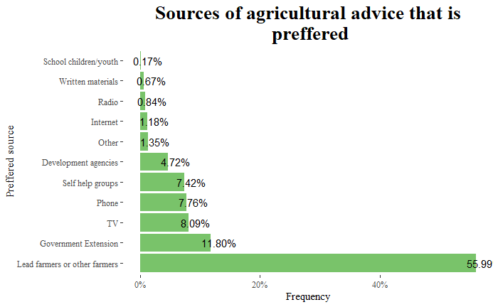

The most preferred source of advice by the farmers is from other farmers, government extensions and TV. More than half the farmers would prefer advice from other farmers.

Figure 5: organization groups

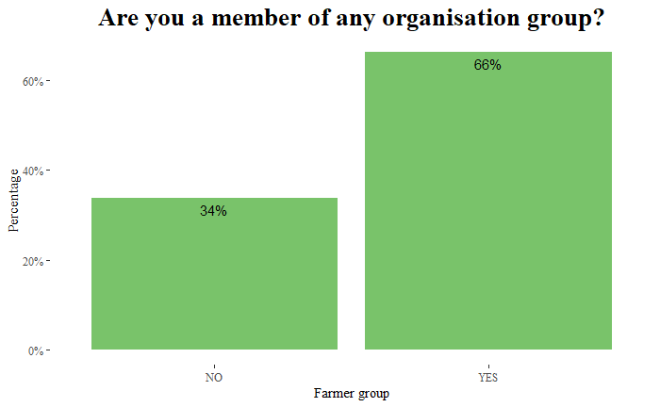

66% of the farmers are in organization groups.

Figure 6: Farmer group types

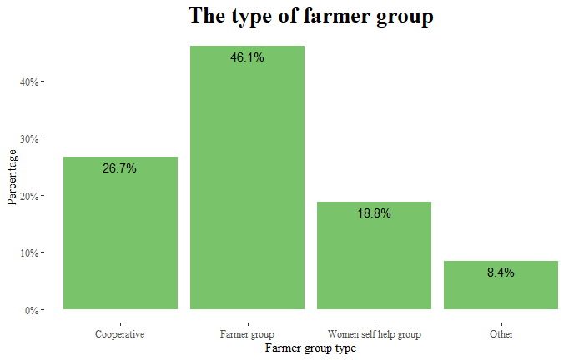

With the different organization types 46% belonged to farmer groups, 26.7% to cooperatives and 18.8% to women self-help groups. This shows that most farmers prefer to be part of the farmer groups because as seen earlier there was an indication that they prefer advice from other lead farmers and this just confirms that.

Figure 7: Benefits from the farmer groups

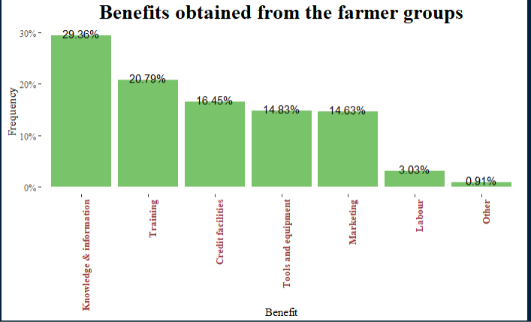

One of the benefits that these farmers get from being part of the farmer groups is knowledge and information, they also get trainings and credit facilities. Other types of benefits are exposure visits and sharing of knowledge.

Figure 8: location of the farm

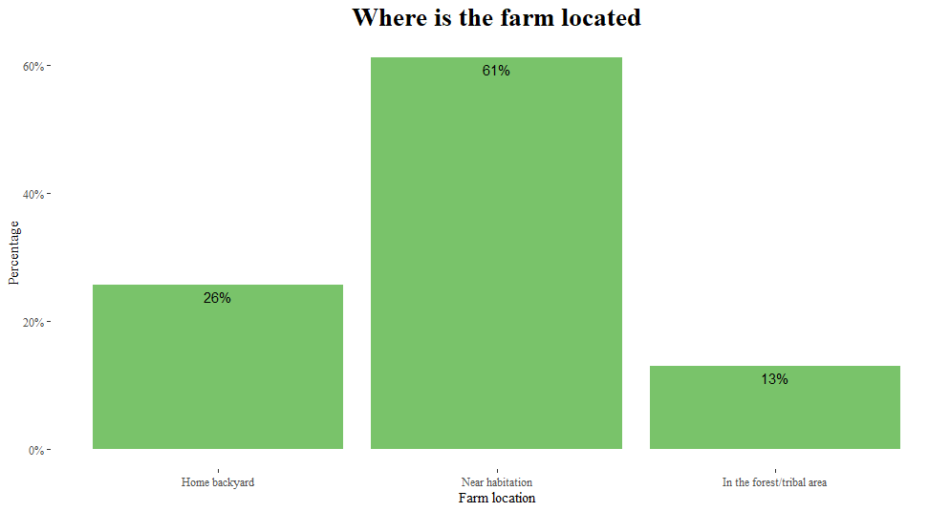

61% of the farms were located near habitations, 26% at the home backyards and 13% in the forest/tribal areas. This shows that many farmers had the farms near their homes.

Figure 9: size of farms

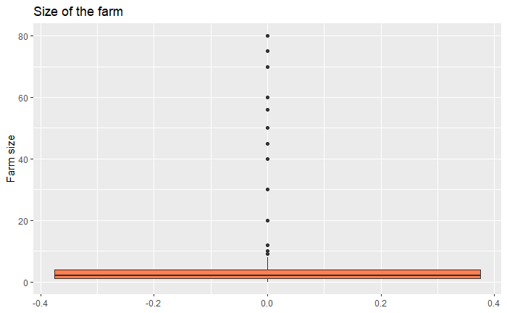

With the size of the farms there is a variation but with outliers with the average being 4.354 and maximum as 80. The lands were measured in acres and only 1 case we had 1 measured in heactares.

Figure 10: land ownership

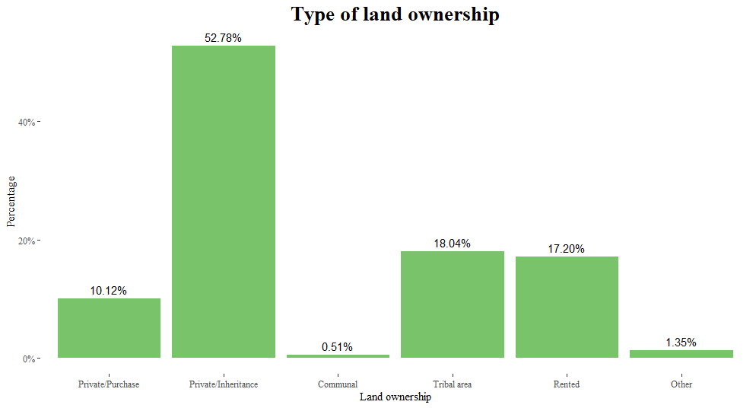

About land ownership most of the land was private through inheritance representing 52.78%, then tribal area 18% then rented at 17.20%. Most the lands are those that are inherited, we see that only 10% have private that is purchased.

Figure 11: cropping area

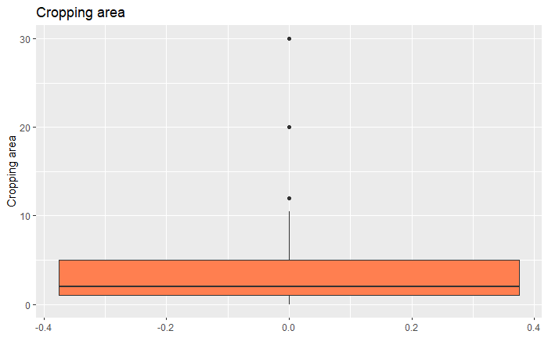

This gives a summary of the cropping area, minimum being 0 and the maximum is 30 acres. The average cropping area is 2.9 acres and the median is 2 acres. Only few farms were above 5 acres.

Figure 12: land use

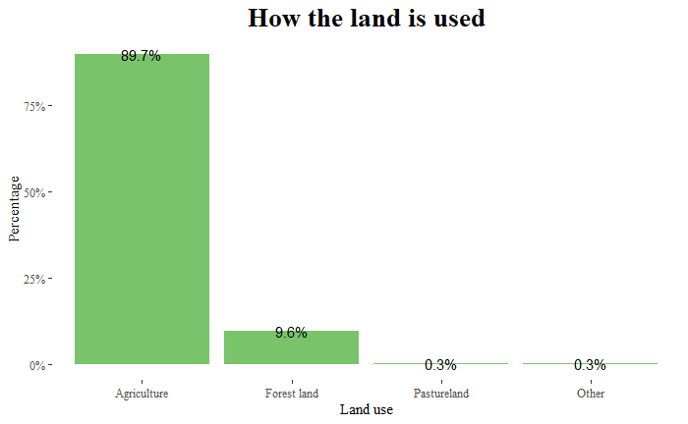

89.7% of the land is used for agriculture and 9.6% is used on forest land while only 0.3% is used as pastureland. This shows that most the farmers were doing agriculture.

Figure 13: soil quality

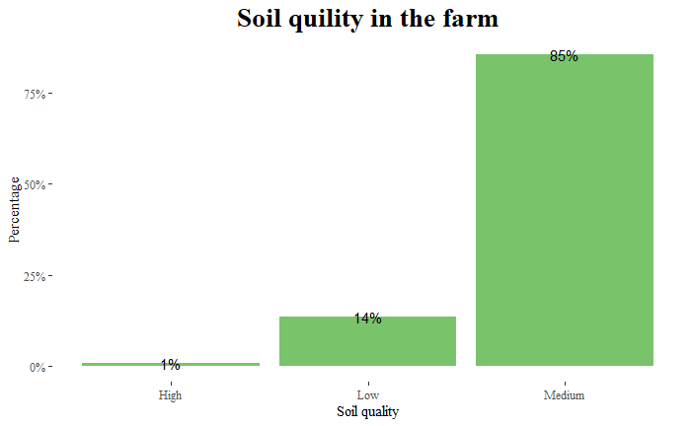

The quality of the soil was medium, only 1% of the soil represented high quality in the region.

Figure 14: soil types

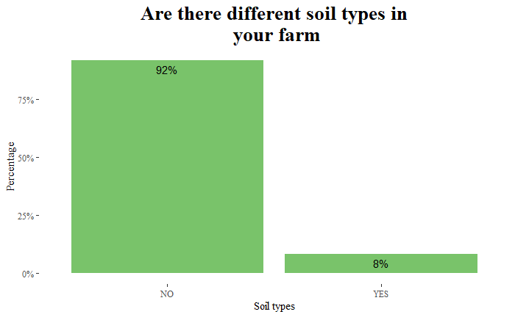

Only 8% said that there farms had different soil types. Among the 8% of those with different type of soil, 92% said that there was 2 types of the soils while 8% said 1 type.

Figure 15: state of soil surface

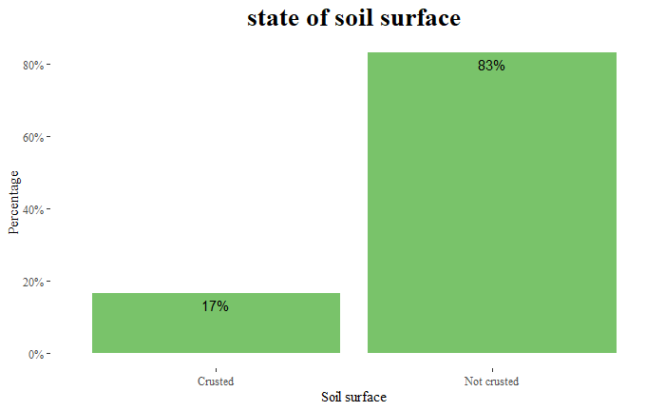

Only 17% of the soil is crusted while 83% is not crusted as in regards to state of the soil surface.

Figure 16: rock cover that has rocks

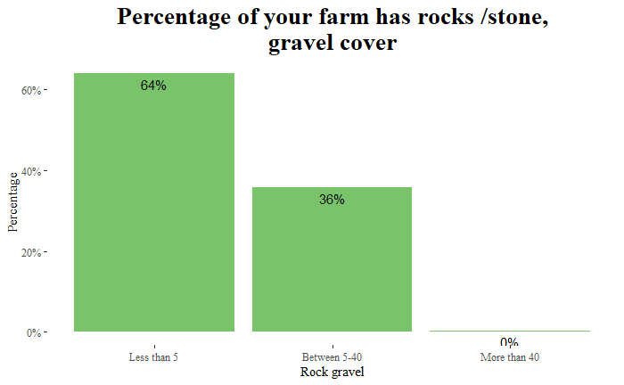

In terms of percentage of the farms that contains rock gravel we see that farm with less than 5% was 64% while between 5 and 40 was 36%. we only had 2 cases were more than 40%.

Figure 17: soil erosion problems

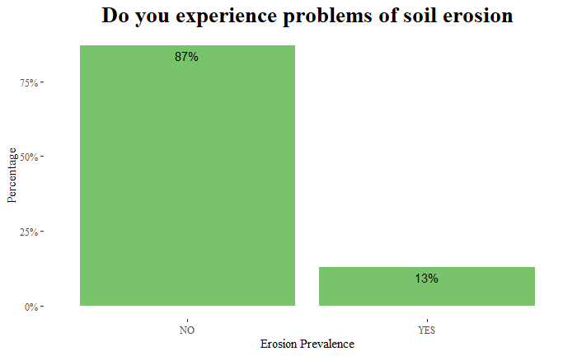

Only 13% of the people experience soil erosion while 87% of the farmers indicated that they do not experience soil erosion problems.

Figure 18: soil erosion type

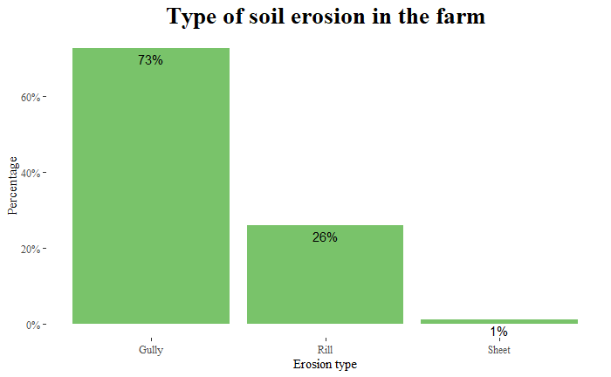

Among the 13% that experience soil erosion problems 73% experience gully erosion, 26% experience rill erosion and 1% face sheet erosion.

Figure 19: measures used to reduce soil erosion

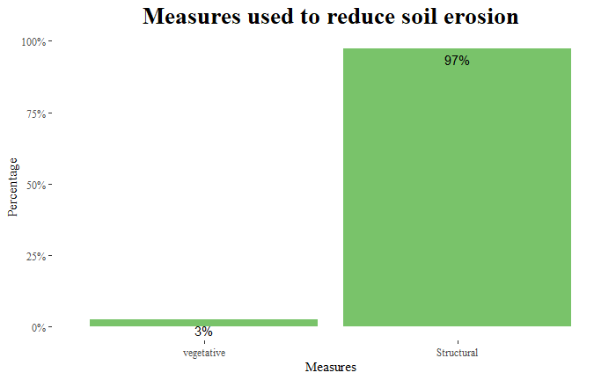

97% of the methods used to reduce soil erosion are structural only 3% of the methods are vegetative.

Figure 20: crop planted in the last 12 months

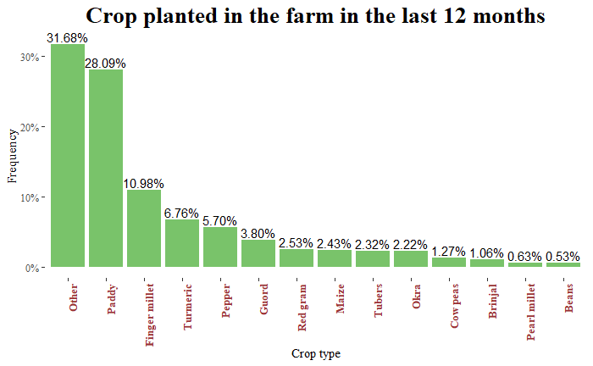

Comparing the crops planted in the farm in the last 12 months we have Paddy as the most common crop planted followed by finger millet, Turmeric, and pepper.

Figure 21: other types of crops

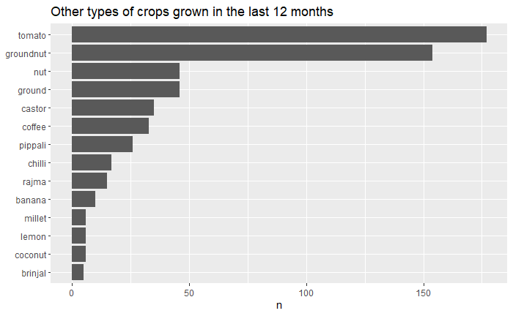

Figure 21 shows that the type of crops grown in the farm were tomatoes, groundnuts, castor, coffee among ones.

Figure 22: factors affecting crop production

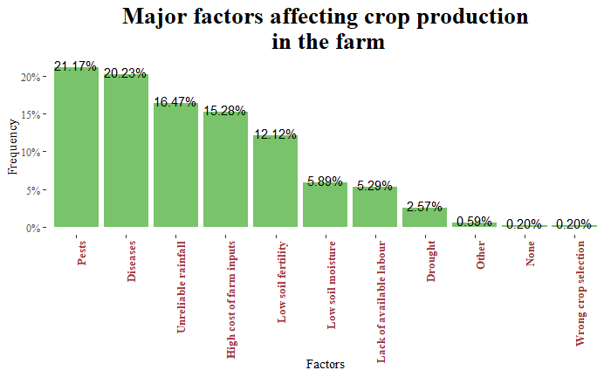

Production is usually the main goal of farming, and it is always key to identify what are some of the challenges affecting this. In this case we see that pests and diseases were the most common factors affecting production this is followed by unreliable rainfall, high cost of farm inputs, low soil fertility etc.

Figure 23: Enhancing crop productivity

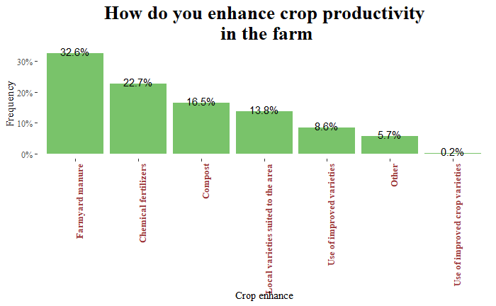

The crop productivity in the farms are highly enhanced by the following methods farmyard manure, chemical fertilizers, compost and local crop varieties suited for the area.

Figure 24: other methods used to enhance productivity

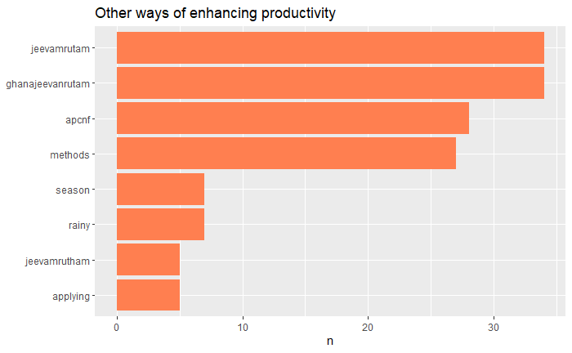

Other methods used for enhancing the crop productivity are jeevamrutam, gvm and APCNF methods.

Figure 25: practice crop rotation

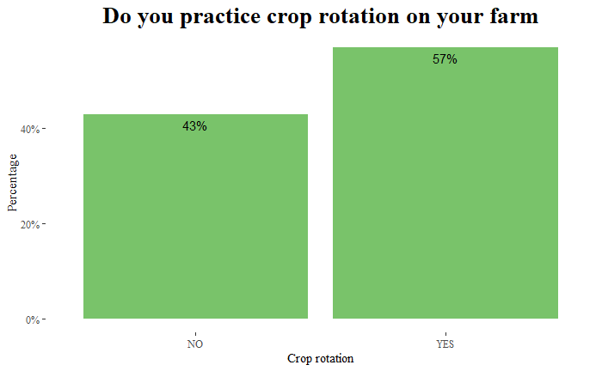

Only 57% of the farmers practice crop rotation.

Figure 26: fallowing

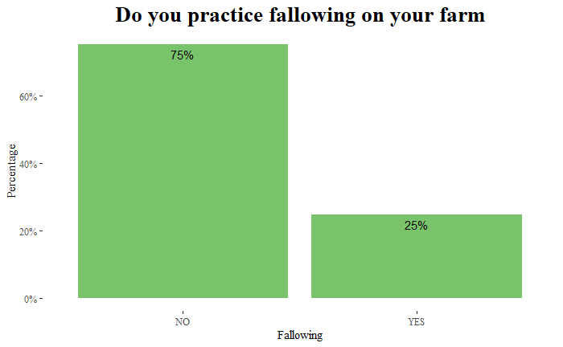

Only 25% of the farmers practice fallowing.

The farm management in terms fallow percent its minimum is 0.1, and maximum is 100 this means that there are those who practice fallowing 100% on their farms. maximum number of years for fallowing is 7 years and minimum is 0.25.

Figure 27: land burnt

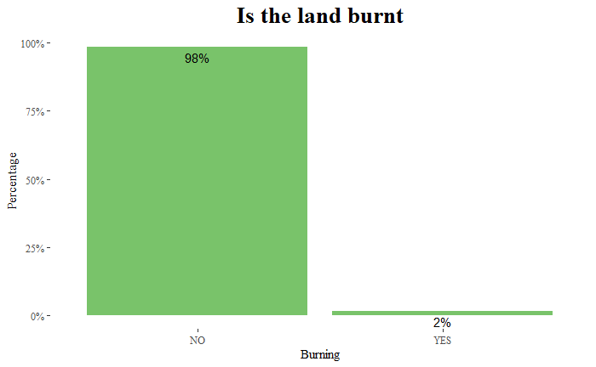

Only 2% of the farms were burnt.

Figure 28: use of crop residues

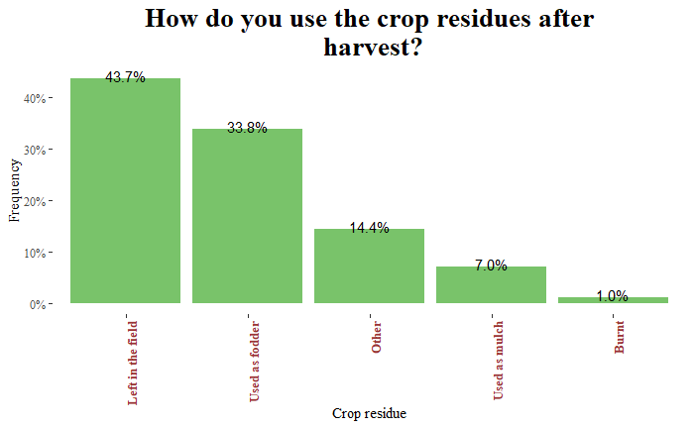

Most of the crop residues after harvest were left in the field that is 43.7%, 33.8% was used as fodder and only 7% was as mulch.

Figure 29: Farmyard manure application

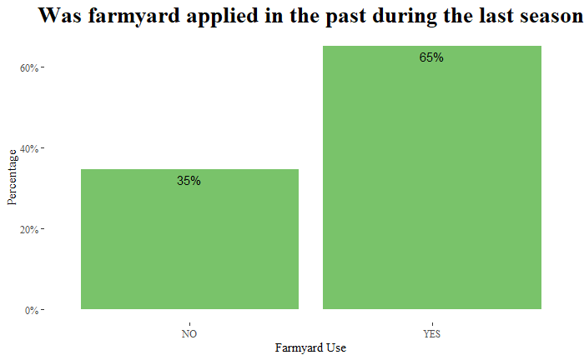

In the last season only 65% of the farmers applied farmyard manure.

Figure 30: crops by farmyard manure

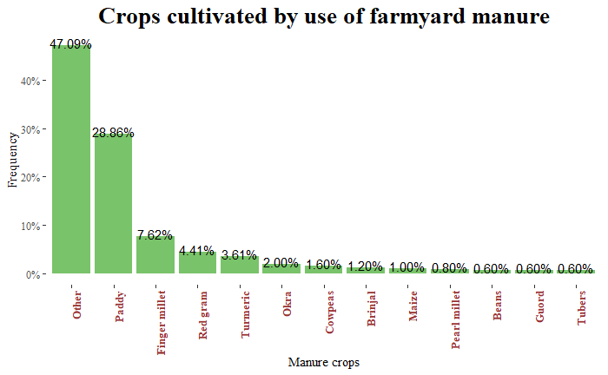

Crops that were cultivated by use of manure are as follows paddy, finger millet, red gram and turmeric. those were the top crops.

Figure 31: compost manure use

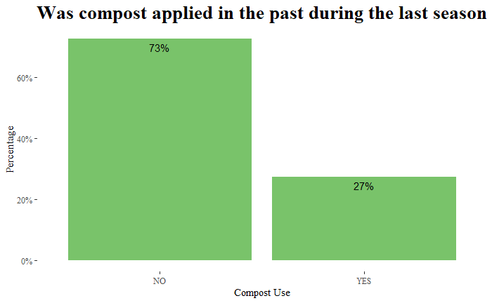

Only 27% of the farmers used compost manure in the last season in their farms.

Figure 32: crops by compost

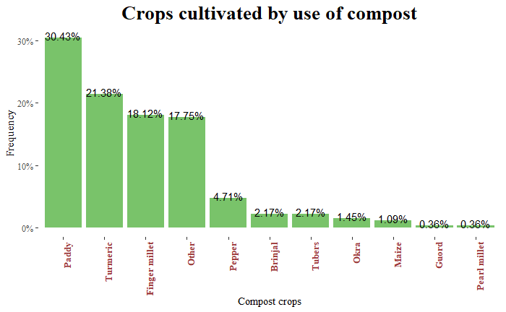

Crops that were with compost are Paddy 30.43%, Turmeric 21.38% and finger millet 18.12%.

Only 3% of the farms is where mulch was applied or used in the past during the last season. With the mulch crops we have red grams, Okra and Tubers as top 3.

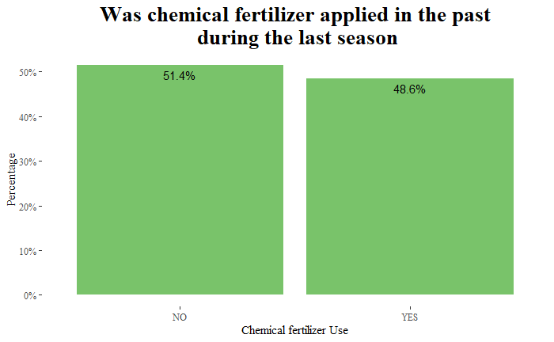

Only 48.6% of the farms was where the chemical fertilizers were applied in the last season, 51.4% did not apply.

Only 17% applied herbicides on the farms. Only 46.2% applied pesticides on the farm.

So the above findings are what I was able to get from the data that was provided and it shows the insights drawn from the data.